E-News Summer 2011 Progress in Motion

  PROSSER EDA
  ANNUAL MEETING
  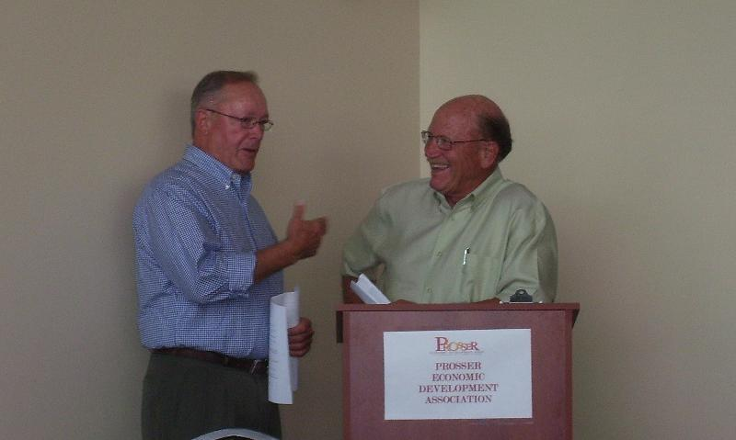
  Co-Chairs Jack Chapman (left) and Mike Hogue (right) of the Walter Clore Wine and Culinary Center were featured keynote speakers at the 2011 Annual Meeting, the first event held at the newly constructed Outdoor Event Facility at the Clore Center.
  Members, partners and guests enjoyed viewing the Clore Centers' new OEF pavilion and newly landscaped grounds on June 6th. Each year Prosser EDA hosts the meeting in appreciation of it's many supporters whose continued commitment plays an integral part in achieving our organizations goals.
  On hand to receive the 2010 Member of the Year Award was Tim Fredrickson, General Manager of Ben - Franklin Transit, pictured right with Deb Heintz, Executive Director.
  Spring Recap
  Jobs and education were an area of focus this Spring. In partnership with both WorkSources' Columbia Basin and Sunnyside; the annual Prosser Job Fair was held on May 5th. The event proved valuable to the community with 17 employers participating and 149 job seekers attending. Job fairs provide beneficial opportunities in a variety of ways; employers are given a chance to explore skill sets offered by prospective employees within our local workforce. Those in search of employment are able to apply for open positions from a wide variety of companies. Agencies are able to field questions, provide program education and assist those in need.
  Long Term Marketing for Small Business, a Winery Sales Workshop, Simple & Effective Business Planning are a few examples of previous workshops offered to the community. By partnering with various agencies, i.e. the Small Business Development Center, Yakima Valley Community College, and others we are able to bring business oriented seminars and classes to members of our community. In May 2011 with assistance from the Benton Franklin Council of Governments, SBDC, and the WA State Micro Enterprise Association, Prosser EDA hosted a six week course assisting workshop participants in developing business plans and providing strategies and tactics for their business to succeed.
  In This Issue
  Annual Meeting
  Spring Recap
  Salute! A Toast For A Grand Opening
  Manufacturing What Industries Are Top 10?
  Community Groups - What's Happening?
  News Items
  WSDA
  Free Pesticide Disposal
  In Prosser
  OLYMPIA - The Washington State Department of Agriculture is sponsoring a free pesticide disposal event this year in Prosser. Advance sign-up is required and deadline for signup is August 31st for the October 20th event.
  WSDA encourages farms, businesses, residents and landowners to inspect their storage sheds, barns, shops and garages. The agency will accept any agricultural and commercial grade pesticides that are no longer needed.
  Call 1-877-301-4555 (toll free) or e-mail: wastepesticide@agr.wa.gov
  to sign up for the event.
  Customers will receive the supplies necessary to protect broken or leaky containers to ensure safe transportation to the collection site, as well as directions to the site, hours of operation and transportation documents. Customer names do not appear on any retained documents. Upon request, WSDA will provide free assistance at a customer's property to help inventory unwanted pesticides and package leaky containers.
  Partner
  Quick Links
  Port of Benton
  City of Prosser
  Benton County
Walter Clore Wine & Culinary Center
A Grand Opening
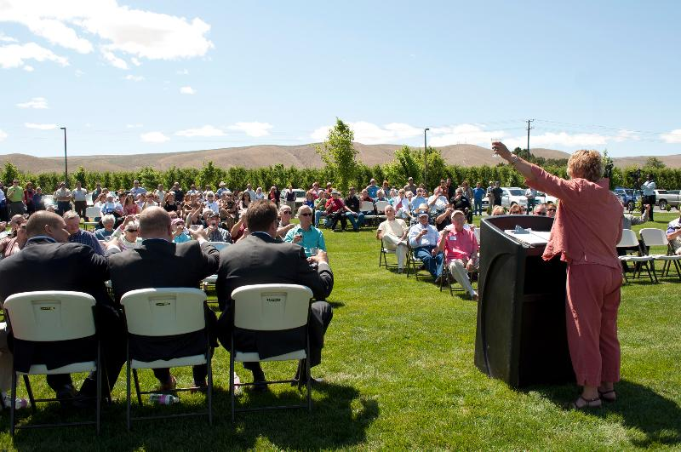
Prosser EDA President, Jane Hagarty raises a glass in honor of Dr. Walter Clore and the completion of the Walter Clore Wine & Culinary Center Outdoor Event Facility

After years of planning and perseverance, the Walter Clore Wine and Culinary Center will begin construction of it's third and final Phase thanks to a $2 million federal grant. Awarded by the federal Economic Development Administration, the final piece of funding needed to implement the project's final stage of development.

Recently completed Phase II, the Center's outdoor event facility, celebrated it's grand opening on June 30th 2011. State and local officials, dignitaries and guests toured the landscaped grounds and 2,400-square-foot event pavilion. The pavilion is used to facilitate events taking place on the grounds. It has a main room seating 50 to 75 people, a catering kitchen, office space and restrooms.
Three of its four main walls are made mostly of glass and can fully open, allowing a party to spill out of the building and onto the grounds. The open patio areas are framed by wooden trellises, which help shade the facility during the summer.

Private donations and various grants over the past several years were used to get the project off the ground in stages. Work began on the site nearly two years ago, after the Port of Benton purchased the property. A mix of state & federal funds and in-kind contributions were used to break ground at the site. Phase I, consisted of infrastructure, water and electricity to the site, lighting, parking lot and curbing and initial light landscaping. Total cost of Phase I, which included purchasing the property, was just over $2.5 million.

The main Clore Center building will be located about 300 yards away from the OEF and include an auditorium with flexible space available for everything from speakers to cooking demonstrations. It will have a demonstration kitchen, a commercial kitchen, tasting room, office space, a conference room and a retail shop. The Center will feature exhibit space to tell the history of wine in the state.

For more information about the Walter Clore Wine and Culinary Center visit the organization's website at www.theclorecenter.org .

Manufacturing - The Decades Top 10 Fastest Growing Industries
As we all know, the manufacturing industry as a whole has been hit hard over the past ten years, losing 4.7 million jobs nationally. However, there are industries within the sector that show growth. The top 10 fastest-growing manufacturing industries from 2001-2010, all showing job gains, are:
- Wineries
- Perishable Prepared Food Mfg.
- Oil and Gas Field Machinery and
Equipment Mfg
- Ship Building and Repairing
- Surgical and Medical Instrument Mfg.
- Ethyl Alcohol Mfg.
- Plastics Pkg. Film and Sheet Mfg.
- Digital Printing
- In-Vitro Diagnostic Substance Mfg.
- Spice and Extract Mfg.

Community Organization Updates
Prosser Farmers Market
Prosser Farmers Market is well underway for the season. Every Saturday, 8 am to 12:00 noon, May through October, visit the Prosser City Park where you can choose from the freshest fruits & vegetables from a wide variety of vendors and select artisan breads, pastries and cheeses that are always available at the Market Booth. Remember, the Market now accepts credit, debit and WA State Quest EBT cards.
Enjoy a pancake breakfast prepared by the Kiwanis or order up a latte, espresso or smoothie from Becky's Coffee Corner. There's musical entertainment each Saturday through September and special events are scheduled throughout the season. Visit their website (just click on their logo) for information, event schedule or to sign up for their E-Newsletter. And . . . to support your favorite market vote here to choose Prosser Farmers Market as your favorite in the American Farmland Trust's national contest.

This May Prosser was named the eleventh Washington State Main Street Community. "A lot of people have been waiting a long time to see this honor come to our community, and so to see it happen is an incredible feeling," says Alisa Groenen, Historic Downtown Prosser Association Executive Director.

Volunteer committees have spent thousands of hours working; implementing a scarecrow contest, monthly movies at the Princess Theater, designs to renovate buildings, add benches & pedestrian amenities to the downtown core and general promotion for the downtown. As a main street community the four committees work toward their mission of having a vibrant and prosperous downtown. The Historic Downtown Prosser Association has worked toward Main Street status since inception in 2005. Check out what's happening downtown, visit their website by clicking on their logo.

Sharon Crosby,
Prosser Economic Development Assn.
www.prosser.org
509 786-3600

Forward email

This email was sent to economicdevelopment@prosser.org by economicdevelopment@prosser.org |
Update Profile/Email Address | Instant removal with SafeUnsubscribe™ | Privacy Policy.
Prosser Economic Development Assn. | 1230 Bennett Avenue | Prosser | WA | 99350

